

Qatar University  
College of Engineering  
Computer Science and Engineering

CMPS350 Web Development Fundamentals   
Spring 2024

Section: L52

Dr. Mucahid Kutlu

Date: 30/03/2024

**Group Project Phase -1**

**THE BOOK HUB**

**GitHub Link:** https://github.com/najwa-na1910314/WebProjectPhase1.git

|  |  |
| --- | --- |
| Najwa Al-Majid | 201901314 |
| Naematul Zannat | 201912964 |
| Hanan Al-Qaood | 201805386 |

**Repository Diagram**

|  |
| --- |
| **bookDetails** |
| findBookIndex(bookId ) |
| fillData(book) |

|  |
| --- |
| **login** |
| validateForm( ) |
| user_login(username, password) |

|  |
| --- |
| **main** |
| filterBooks(searchQuery) |
| showFilteredBooks(booklist) |
| loadPage(pageUrl) |
| formToObject(form) |
| fetchBooks( ) |
| showBooks( ) |
| page(pageUrl) |
| buyBook(bookId) |
| toHTML(book) |

|  |
| --- |
| **sellBook** |
| addBook(event) |
| getBooksFromLocalStorage() |
| loadSellerSales() |

|  |
| --- |
| **sellBook** |
| addBook(event) |
| getBooksFromLocalStorage() |
| loadSellerSales() |

|  |
| --- |
| **uploadBook** |
|  |
|  |
|  |

**Use Case 01 Testing**

* If the user enters an incorrect username or password, an error message will appear that is " Unregistered user!"

* If the user enters a correct username and password, then the system will check which type of user he is. If has a customer the system will direct him to the main page.



**Use Case 02 Testing**

* **There is no available item:**



* **There are some available items:**



* **There are some available items:**

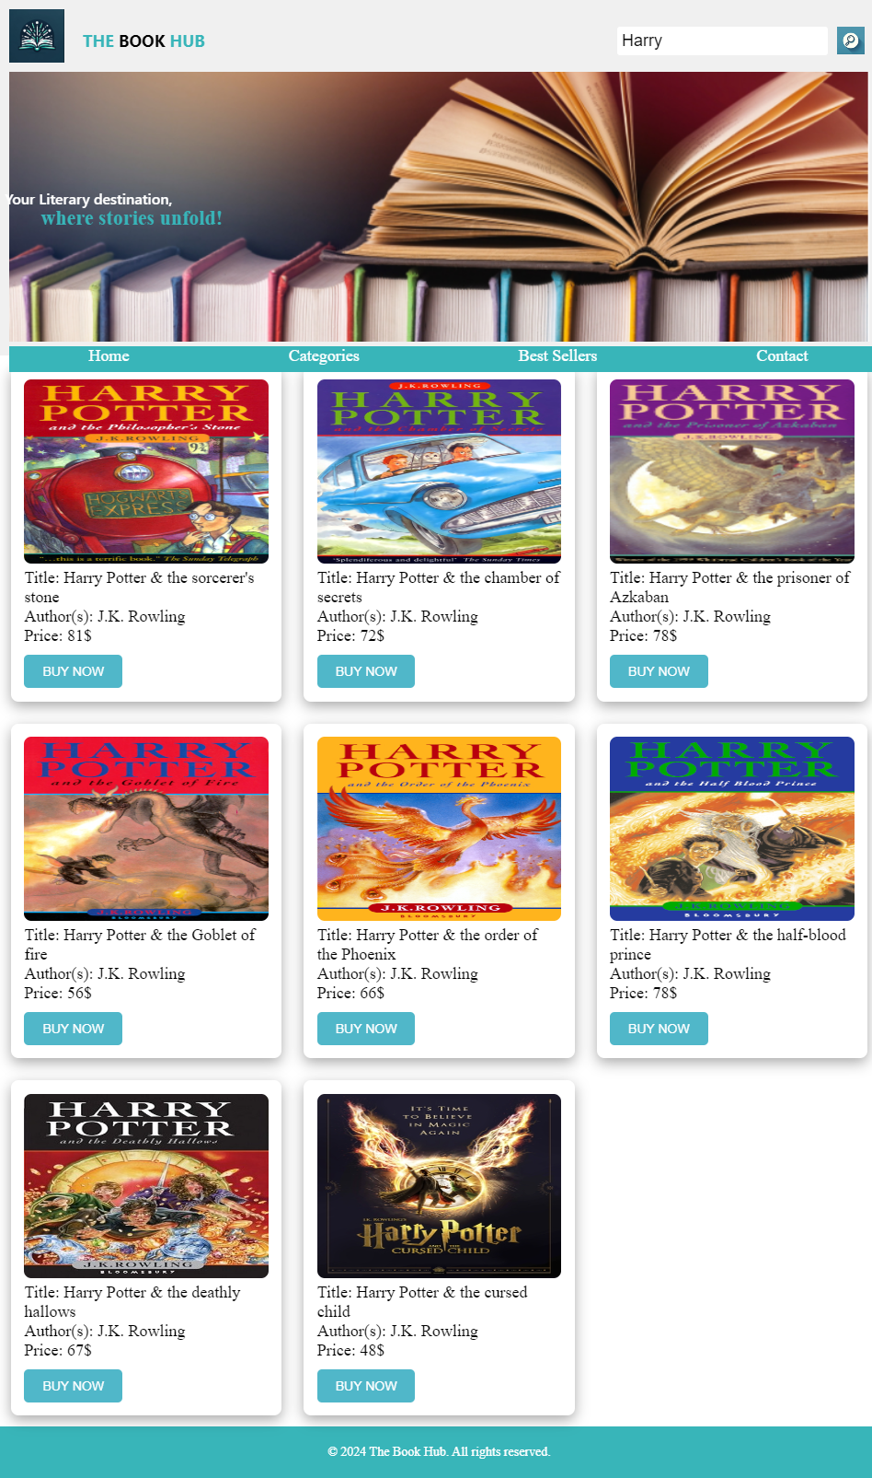

**Use Case 03 Testing**

***<Add Screenshot below with explanation>***

**Use Case 04 Testing**

When the user presses on the confirm purchase from the previous use case, this will save the books ordered to the customerOrder.html.

**Use Case 05 Testing**

**Use Case 06 Testing**

